# Patent Failure, Researcher Failure, Archive Failure: Getting Inventive With the Study of Inventions

### Kat Jungnickel

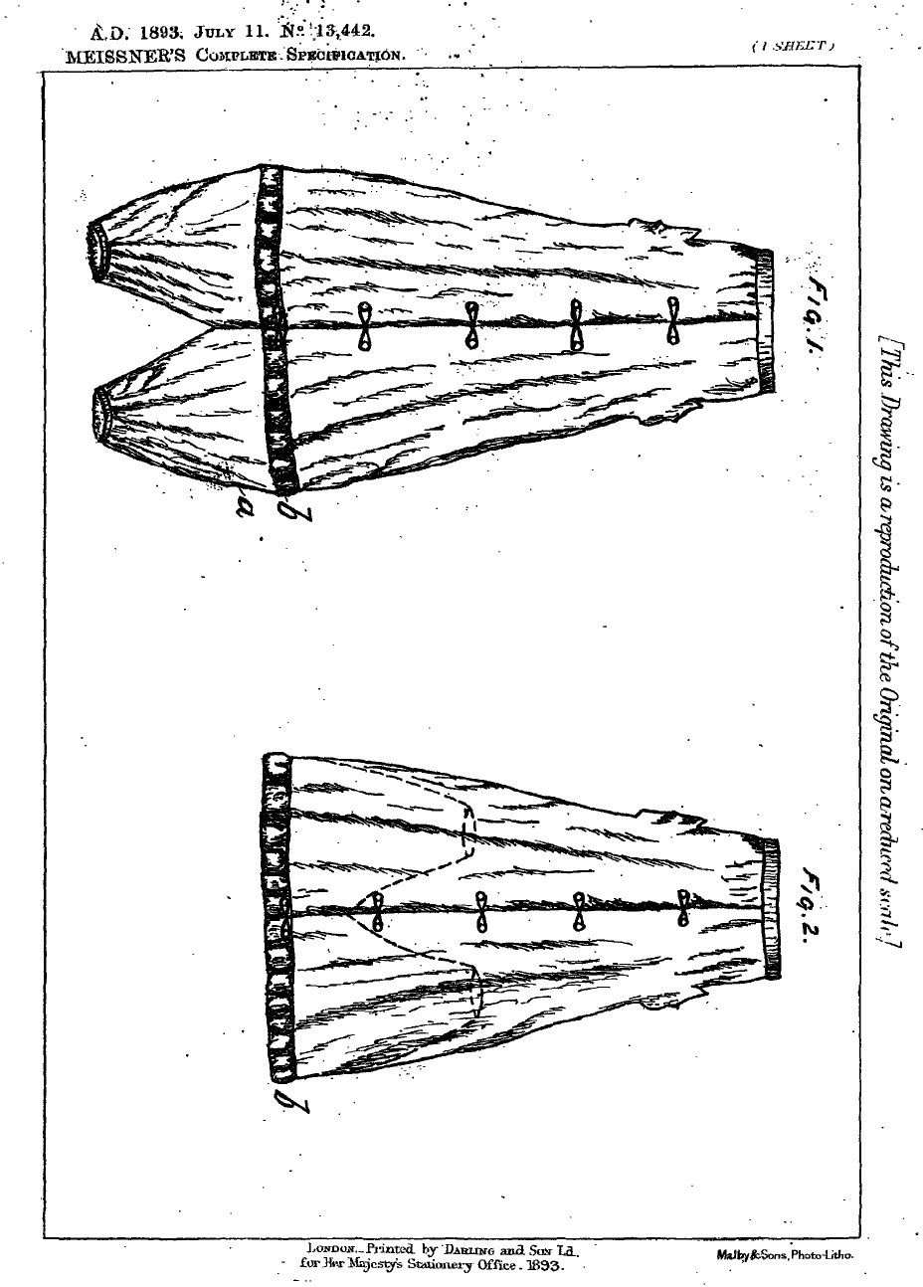

Figure 4.1: Drawings from Sidonie Meißner’s 1893 patent for a ‘Garment for Lady Cyclists’[1]

I, SIDONIE MEIßNER of Grosse Brudergasse, Dresden, in the German Empire, Spinster, do hereby declare the nature of this invention […] to provide for lady cyclists a garment which allows of a convenient working of the treadles, serves as a protection against dust and dirt and keeps covered the upper part of the leg. The garment terminates at bottom in a trouser, the two lower ends of which are drawn in by rubber or elastic binding. The garment is buttoned down the front as shewn [sic] and may have the form of an ordinary coat with trouser like extensions which in use are drawn upwards within the body and it is drawn in at the waist in the ordinary manner at the upper band. Suitable pockets may be provided.

I start this chapter with drawings and words by Sidonie Meißner, an inventor living in Germany in 1893. She applied for a patent for a ‘Garment for Lady Cyclists’ at the British Patent Office — with the assistance of Patent Agents in Chancery Lane, London — on 11th July, and it was accepted on 23rd September in the same year. It responded to a cycling craze sweeping Europe in the late nineteenth century. Both women and men were enthusiastic early adopters of the bicycle, but they experienced it very differently.[2] Early women cyclists suffered intense social scrutiny, because like many Victorian sports, cycling was considered the ‘natural domain of men’.[3] They were pressured to maintain ‘feminine dignity’ regardless of the activity, and to avoid looking hot, dishevelled, or dirty.[4]

Yet, cycling was not only a highly public activity but also an intensely physical one. Long skirts appropriate for walking were largely incompatible with the moving machinery of the bicycle. In many cases looking dishevelled was the least of their problems. Materials caught the wind and blew up, revealing legs, and tangled in wheels and pedals. Newspapers regularly reported on deaths and disfigurements from cycle crashes caused by women’s clothing. Unsealed roads were also a reality which made cycling a dusty and often muddy experience. While wearing more ‘rational dress’ such as shorter skirts or swapping them entirely for bloomers or knickerbockers might have been safer and more comfortable, it exposed the wearer to different dangers. Writing about the experience of cycling in England in the 1890s, Irene Marshall[5] explains:

Caps, stones, road refuse — anything was then flung at the hapless woman who dared to reveal the secret that she had two legs. And the insults were not confined to the lower classes. Well-dressed people, people who would be classed as ladies and gentlemen, frequently stopped and made rude remarks.

Yet nothing was going to stop women from cycling once they experienced the freedom and independence promised by the bicycle. Late Victorian Britain was an exciting time for new ideas, technologies, and media. The cycling boom corresponded with patent system reform and opened the process of claiming an inventive idea to a broader range of inventors. Along with the many social and sartorial challenges facing women, these conditions catalysed much inventive activity by and for women. This chapter focuses on inventions for convertible cycling skirts which enabled wearers to safely cycle while also concealing evidence of their athletic activities as and when needed.

Sidonie Meißner’s invention does this and more. From the outside her ‘Garment for Lady Cyclists’ looks like an ordinary long skirt yet it includes excess fabric shaped into ‘pop out’ leggings concealed under the lower hem. She explains it’s triple aim; to provide freedom of movement to cycle, to keep pedalling legs covered, and to protect the wearer from ‘dust and dirt.’ Her suggestion for ‘suitable pockets’ is also reflective of independent women’s desire to carry goods and free their hands. ‘No pocketless people’, asserted a male *New York Times* writer in 1899, ‘has ever been great since pockets were invented, and the female sex cannot rival us while it is pocketless.’[6]

I know all these related contextual insights from years of research on this topic. While Sidonie Mießner’s patent data is valuable and points to lots of rich topical issues to explore, I’m looking for more. Yet her patent only provides half a page of text and two intriguing line drawings. It is tantalisingly brief. And I haven’t been able to access anything else more directly related to her. As a result, I know very little about the inventor or what happened to her specific invention.

There are several potential reasons for this.

My initial response is to worry that I had failed as archive researcher. Did I miss extra data about her life in the archives? Did I overlook a critical fragment of her life somewhere? Was there a snippet of text or an image I flicked past that would have led me down new and untravelled paths? Maybe more is still out there. As researchers, we seek threads across archives; serendipitous connections, sharp moments of association when a visual fragment from one archive suddenly slots into place with text from another. I know this feeling. I have celebrated on my own very quietly in dusty stacks with joy and relief when something like this happens. But not here. Not now. Sidonie Mießner’s life eludes me.

Another possibility is that the inventor failed. Perhaps this is all there is. Was she unsuccessful in securing a future for her patent? Did her invention fail to leave the patent office records? Did no one see any potential in it? There is no trace of it being commercialized or distributed. There was no launch event. There is no evidence that anyone talked about, made, or wore it. There is nothing about her or her invention in newspapers, magazines, or periodical archives.

## Data: Too Much, Not Enough

In past projects I conducted ethnography with live people. I visited them in their homes, climbed onto their rooftops, spent time in their backyard sheds, went cycling with them, and discussed their relationships with technology, public space, and each other. Data was everywhere. All too frequently, issues in research emerge from having too much of it. [7] Ethnographic texts commonly discuss being ‘overwhelmed’, ‘unnerved’, and ‘daunted’ by data. Learning how to make sense and order it is much harder. Archival analysis can feel similar, in many circumstances. For example in *Dust*, Carolyn Steedman writes at length about the overwhelming feeling of dealing with a tsunami of stuff people have left behind:

Archive fever comes on at night, long after the archive has shut for the day…. Everything. Not a purchase made, not a thing acquired that is not noted and recorded. You think: I could get to hate these people and, I can never do these people justice, and, finally: I shall never get it done […] Your anxiety is that you will not finish, that there will be something left unread, unnoted, untranscribed […] Your craft is to conjure a social system from a nutmeg grater.[8]

But, what do we do with a nutmeg grater and very little nutmeg?

I felt adrift and mildly panicked the first time this happened. The feeling was amplified as I had just spent a giddy few days finding many exciting connections across archives about another inventor. Now, I had this. Nothing. Zilch. Sidonie Mießner was nowhere to be found. What would I do if I couldn’t find anything about her or her invention? What kind of a patent researcher was I? What could I do in this research dead end? What would I write about?

But, maybe it wasn’t just Sidonie Meißner’s or my fault.

Another site of failure lies with archives themselves. Not everything is recorded about everyone. Or even if they are, over time archival data can get lost, ignored or systematically erased.

Sidonie Mießner may have filed her patent in Britain, but she resided in Germany. Lots of archival data went missing or was destroyed in wartime. Apparently, ‘World War II resulted in the greatest loss and displacement of cultural treasures, books, and archives in history.’[9] While her name seems distinct, and generates several promising genealogical results, nothing can be certain. This is partly because she self-identifies as a spinster. Even though their last names change, it is sometimes easier to find women if they are married (as there are more records about the men in their lives).[10] Her patent unfortunately doesn’t provide any information about her vocation (either she didn’t have one or it wasn’t considered important, as was the case for much women’s documentation in archives).

Many inventions, especially those of women, were renamed when they were commercialized, which makes them even harder to trace. Being a woman made it even harder to succeed in business at the time (as she most likely lacked socio-political capital, networks, and funds). Even worse, being a spinster was viewed as a failure by parts of society. For some ‘the state of singleness for women was a most “unfortunate” condition.’[11]

## Archives: Biased, Messy, and Troublesome

Archives always tell certain stories about specific people, places, and times. Much like maps, archives are powerful devices that simultaneously convey and conceal knowledge, are shaped by political norms and beliefs, and predominantly assembled by a victor with an explicit purpose in mind. Archives ‘are not innocent sites of storage’ but rather ‘already texts shaped according to interests and needs of certain groups’.[12] Queer and feminist archivists and historians have long drawn attention to and questioned the politics that shape collections and encourage readers to see not only what is present but also what is absent.

As technofeminist Ruth Schwartz-Cowan reminds, ‘the absence of a female perspective in the available histories of technology was a function of the historians who write them and not of the historical reality.’[13] For Anne Stoler, a feminist turn in the archives involves a ‘move from archive as source *to* archive as subject.’[14] She talks about ‘archiving as a process’ rather than ‘archives as things.’[15] This work reorients the reading of the past as a way to critique the political and colonial contexts of knowledge and knowledge makers. The lack of data about women is especially troublesome. Women tend to go unrecorded in official accounts, especially technological and cycling histories. Patents are valuable in this context as they ‘present a valuable perspective on female inventive activity and market participation in an era when marriage meant the virtual “invisibility” of married women in terms of objective data.’[16]

None of this means that Sidonie Mießner didn’t exist, of course, or that her patent wasn’t successful or that her invention wasn’t made, worn, and enjoyed by early women cyclists. The task becomes how to reconstruct her life and invention when there are few traces in the archives.

What to do with flawed archival data? Or in this case, the lack of flawed archival data?

## Experimental Approaches to Archival Research

Inspiration can be found in many creative and experimental approaches to archive research. Writing about queer filmmaker Cheryl Dunye’s practice, Julia Bryan-Wilson explains how ‘Dunye has consistently explored the affective potency that lies within historical records — and the gaps in those records — to explore how fictional archives might be necessary for queer lives in the present as well as for imagined futures’.[17] Feminist archivists Nydia Swaby and Chandra Frank take a different sensory approach: ‘We are invested in exploring the experimental as a means to read, experience, feel and touch archives’ and ‘as an imaginary, in which we deliberately make space for play, refusal and artistic renderings of archives and their materiality’.[18] They also ‘propose experimentation as a form of dwelling and lingering in the archive to subvert linear notions of time and place’.[19]

Even more directly, African-American scholar Saidiya Hartman creatively challenges the authority of historical data that ‘dictates what can be said about the past and kinds of stories that can be told about the persons catalogues, embalmed, and sealed away in a box of files and folios’.[20] Her powerful work reads ‘against the grain, disturbing and breaking open the stories’ which requires her ‘to speculate, listen intently, read between the lines, attend to the disorder and mess of the archive, and to honor the silence.’[21]

Although diverse, these writers collectively take political positions in their work by identifying and rendering visible the ‘telling blanks and perversely wilful holes’ in archives.[22] Guided by this inspiring interdisciplinary work, failures and gaps in archives can be seen as invitations to find, piece together, and convey new stories or alternate perspectives on existing ones. A dead end in the archives is not terrible. It does not mark the end of a project. Rather, as I am learning, there are many ways of responding to it. In the case of Sidonie Mießner’s patent, it enabled me to get inventive with the study of invention. As Celia Lury and Nina Wakeford have argued, ‘Inventive methods are ways to introduce answerability into a problem […] if methods are to be inventive, they should not leave that problem untouched’.[23]

My practice involves the use of what I term ‘speculative sewing’, whereby I ‘stitch data, theory and fabric into inventions described in patents and analyse them as three-dimensional arguments’.[24] The lack of surviving data about the invention and/or the invention itself can be partially rectified by remaking it. The patent after all is a step-by-step series of instructions for future users to replicate an inventor’s idea. For my research team, the process of researching, reconstructing, and re-imagining lesser known technoscience stories into material forms offers ways to spend time with the inventor, interview her about her practice, make mistakes, take tangents, and reflect on the process.

This practice reveals the complexities of the invention often hidden in (brief) texts. Physically getting up close to and into the research and reflecting on the intimacy of making and wearing other people’s clothes adds new and different textures and layers to the analysis. This approach to failure can be seen as a political act of visibility. The materiality of a convertible cycling skirt marks a firm counter argument to the invisibility of the inventor in other forms of official and formal records.

## Getting Inventive with Failure

This chapter started with questions about failure. I asked who or what was central to the problem of not finding data about the inventor Sidonie Mießner’s life and her invention. Research rarely takes us in the direction we initially expect. And even, as mapped out above, when we start to approach seemingly stressful dead ends there are sometimes inventive ways out. Reflecting on the work of scholars who approach failure in archives in creative and experimental ways encourages us to read ‘against the grain’.[25]As Swaby and Frank remind us, ‘the archive is as much a site of loss as of abundance’.[26]

## Bibliography

‘Bicycling News and Sport and Play. Lines for Ladies by Marguerite’, quoting from ‘The Compromises of Cycling’ in *Hearth and Home*, 28 May 1895, 34.

Bryan-Wilson, Julia and Dunye, Cheryl. ‘Imaginary Archives: A Dialogue’, *Art Journal* 72.2 (2013): 82-89.

Fetterman, David, M. *Ethnography: Step by Step*. 3rd edition, Applied Social Research Methods Series 17, London: Sage, 2010.

Hammersley, Martin, and Atkinson, Pau. *Ethnography: Principles in Practice*, 3rd edition, London and New York: Routledge, 2007.

Hargreaves, Jennifer. *Sporting Females: Critical Issues in the History and Sociology of Women’s Sports,* London and New York: Routledge, 1994.

Hartman, Saidiya. *Wayward Lives, Beautiful Experiments: Intimate Histories of Riotous Black Girls, Troublesome Women and Queer Radicals*, London: Serpent’s Tail, 2021.

­­­____. *Lose Your Mother: A Journey Along the Atlantic Slave Route*, London: Serpent’s Tail, 2007, 17.

Holmes, Katie. ‘‘Spinsters Indispensable’: Feminists, Single Women and the Critique of Marriage, 1890-1920,’ *Australian Historical Studies*, 29.100: 68-90.

Jungnickel, Kat. ‘Speculative Sewing: Researching, Reconstructing And Re-Imagining Clothing Inventions As Wearable Technoscience’, *Social Studies of Science*, online first 16 Aug 2022, https://journals.sagepub.com/doi/10.1177/03063127221119213.

____. *Bikes and Bloomers: Victorian Women Inventors And Their Extra-Ordinary Cyclewear*, London: Goldsmiths Press, 2018.

Kennedy Grimstead, Patricia. ‘Spoils of War Returned’, *Prologue Magazine*, 34. 2 (2002), https://www.archives.gov/publications/prologue/2002/spring/spoils-of-war-1.

Khan, Zorina B. ‘Married Women’s Property Laws and Female Commercial Activity: Evidence From United States Patent Records, 1790-1895’, *The Journal of Economic History* 56.2 (1996): 356—388, 365-6.

Lury, Celia and Wakeford, Nina (eds). *Inventive Methods: The Happening of the Social*, London and New York: Routledge, 2012.

Marshall, Irene. *The Rational Dress Gazette, Organ of the Rational Dress* *League* - *Correspondence*, No. 10, July 1899, 40.

Meißner, Sidonie. *Patent GB189313442A ‘Garment for Lady Cyclists’*, 23 September 1897, [www.epo.org](http://www.epo.org).

*The New York Times*, ‘World’s Use of Pockets,’ 28 August 1899.

Pollock, Griselda. ‘Trouble in the Archives’, *Women’s Art Magazine* 54 (1993): 10-13.

Schwartz-Cowan, Ruth. *A Social History of American Technology*, Oxford, UK: Oxford University Press, 2007.

Steed, Caroline. ‘Something She Called Fever: Michelet, Derrida and Dust’, *The American Historical Review*, 106.4 (2001): 1159-1180.

Stoler, Kate. ‘Colonial Archives and the Arts of Governance’, *Archival Science* 2 (2002): 87-109.

Swaby, Nydia A and Frank, Chandra. ‘Archival Experiments, Notes and (dis)Orientations,’ *Feminist Review* 125 (2020): 4-16.

1. Sidonie Meißner, *Patent GB189313442A ‘Garment for Lady Cyclists*’, 23 September 1897, [www.epo.org](http://www.epo.org).
2. For more discussion in these issues see Kat Jungnickel, *Bikes and Bloomers: Victorian Women Inventors And Their Extra-Ordinary Cyclewear*, London: Goldsmiths Press, 2018.
3. Jennifer Hargreaves, *Sporting Females: Critical Issues in the History and Sociology of Women’s* Sports, London and New York: Routledge, 1994, 43.
4. ‘Bicycling News and Sport and Play. Lines for Ladies by Marguerite’, quoting from ‘The Compromises of Cycling’ in *Hearth and Home*, 28 May 1895, 34.
5. Irene Marshall. *The Rational Dress Gazette, Organ of the Rational Dress* *League* – *Correspondence*, No. 10, July 1899, 40.
6. *The New York Times,* ‘World’s Use of Pockets,’ 28 August 1899, 7.
7. See for example Martin, Hammersley and Paul Atkinson, *Ethnography: Principles in Practice*, 3rd edition, Oxon: Routledge, 2007; David, M. Fetterman, *Ethnography: Step by Step*. 3rd edition, Applied Social Research Methods Series 17, London: Sage, 2010.
8. Caroline Steed, ‘Something She Called Fever: Michelet, Derrida and Dust’, *The American Historical Review*, 106.4 (2001): 1159-1180, 1164-5
9. Patricia Kennedy Grimstead, ‘Spoils of War Returned’, *Prologue Magazine*, 34. 2 (2002), https://www.archives.gov/publications/prologue/2002/spring/spoils-of-war-1.
10. For example, ancestry records provide lots of accounts of Sidone Meißners. A Sidonie Elise Mießner was born 29 Feb 1868 in Erfurt, Germany. This would make her quite young, 21 years old, at the time of her patent. However, she was married to Emile Richard Fuhrman. Another Sidonie was born 1855 in Dresden (making her 42 in 1897). She was also married to a Hugo Roßner.
11. Katie Holmes, ‘‘Spinsters Indispensable’: Feminists, Single Women and the Critique of Marriage, 1890-1920,’ *Australian Historical Studies*, 29.100: 68-90, 68.
12. Griselda Pollock, ‘Trouble in the Archives’, *Women’s Art Magazine* 54 (1993): 10-13, 12.
13. Ruth Schwartz-Cowan, *A Social History of American Technology*, Oxford, UK: Oxford University Press, 2007, 120.
14. Kate Stoler, ‘Colonial Archives and the Arts of Governance’, *Archival Science* 2 (2002): 87-109, 93
15. Stoler, ‘Colonial Archives’, 87.
16. Zorina B. Khan, ‘Married Women’s Property Laws and Female Commercial Activity: Evidence From United States Patent Records, 1790-1895’, *The Journal of Economic History* 56.2 (1996): 356—388, 365-6.
17. Julia Bryan-Wilson and Cheryl Dunye, ‘Imaginary Archives: A Dialogue’, *Art Journal*, 72.2 (2013): 82-89, 83
18. Nydia A Swaby and Chandra Frank, ‘Archival Experiments, Notes and (dis)Orientations,’ *Feminist Review* 125 (2020): 4-16, 4.
19. Swaby and Frank, ‘Archival Experiments’.
20. Saidiya Hartman, *Lose Your Mother: A Journey Along the Atlantic Slave Route*, London: Serpent’s Tail, 2007, 17.
21. Saidiya Hartman, *Wayward Lives, Beautiful Experiments: Intimate Histories of Riotous Black Girls, Troublesome Women and Queer Radicals*, London: Serpents Tail, 2021, 34.
22. Bryan-Wilson and Dunye, ‘Imaginary Archives’, 82.
23. Celia Lury and Nina Wakeford (eds), *Inventive Methods: The Happening of the Social*, London and New York: Routledge, 2012, 3.
24. Kat Jungnickel, ‘Speculative Sewing: Researching, Reconstructing And Re-Imagining Clothing Inventions As Wearable Technoscience’, *Social Studies of Science*, online first 16 Aug 2022, https://journals.sagepub.com/doi/10.1177/03063127221119213.
25. Hartman, *Wayward Lives,* 34.
26. Swaby and Frank, ‘Archival Experiments’, 11.